Newspaper Puppets
Circle Ten Council
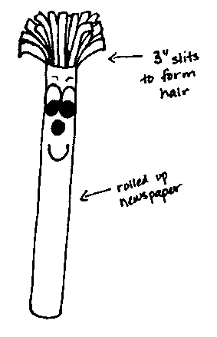
Materials: Newspaper, scotch tape, and white paper
Directions:
- Pile at least five pages of newspaper together.
- Fold them in half (so they are about 11 x 14) and roll them up lengthwise. Make sure that the roll is tight.
- Fold another page in half and wrap it around the roll.
- Tape them all together.
- From the top of the roll, make cuts about three inches long and 1/2 inch apart to make the hair.
- Draw eyes, nose and mouth on the white paper and cut them out. Glue the facial features on the roll just below the hair.

